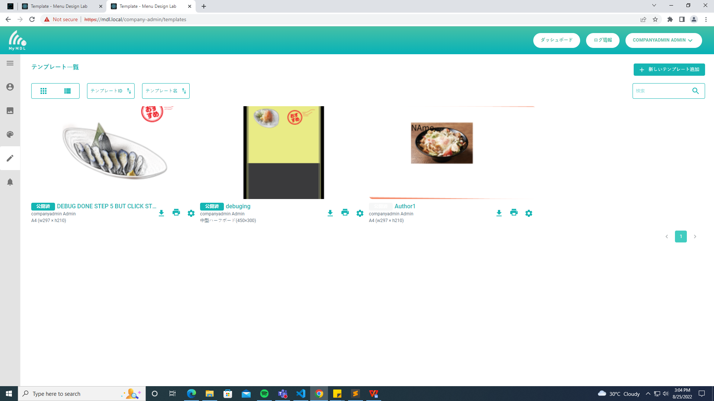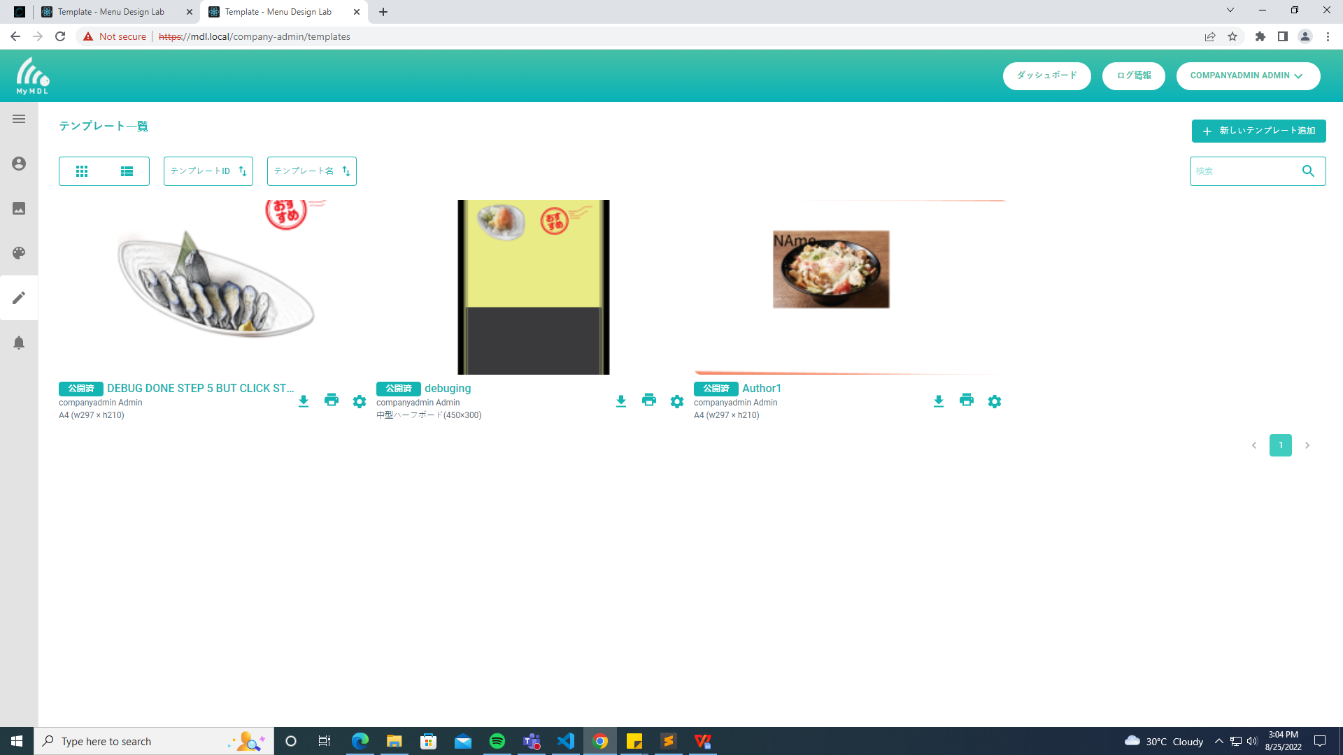

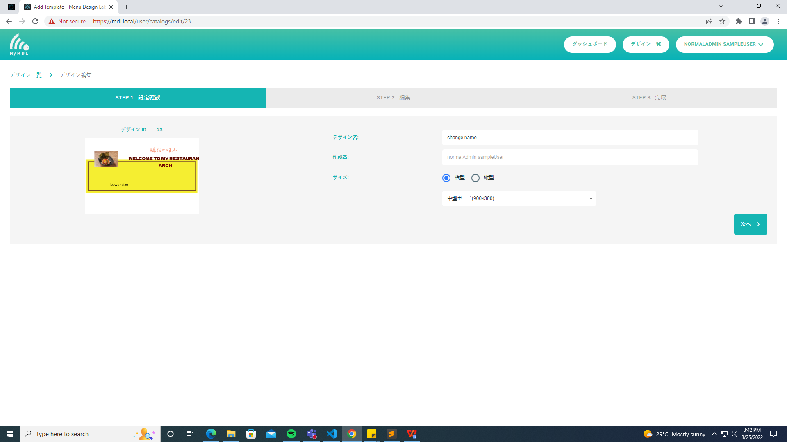
Step 1
450X300 EDIT, CHANGE TO 900 X 300

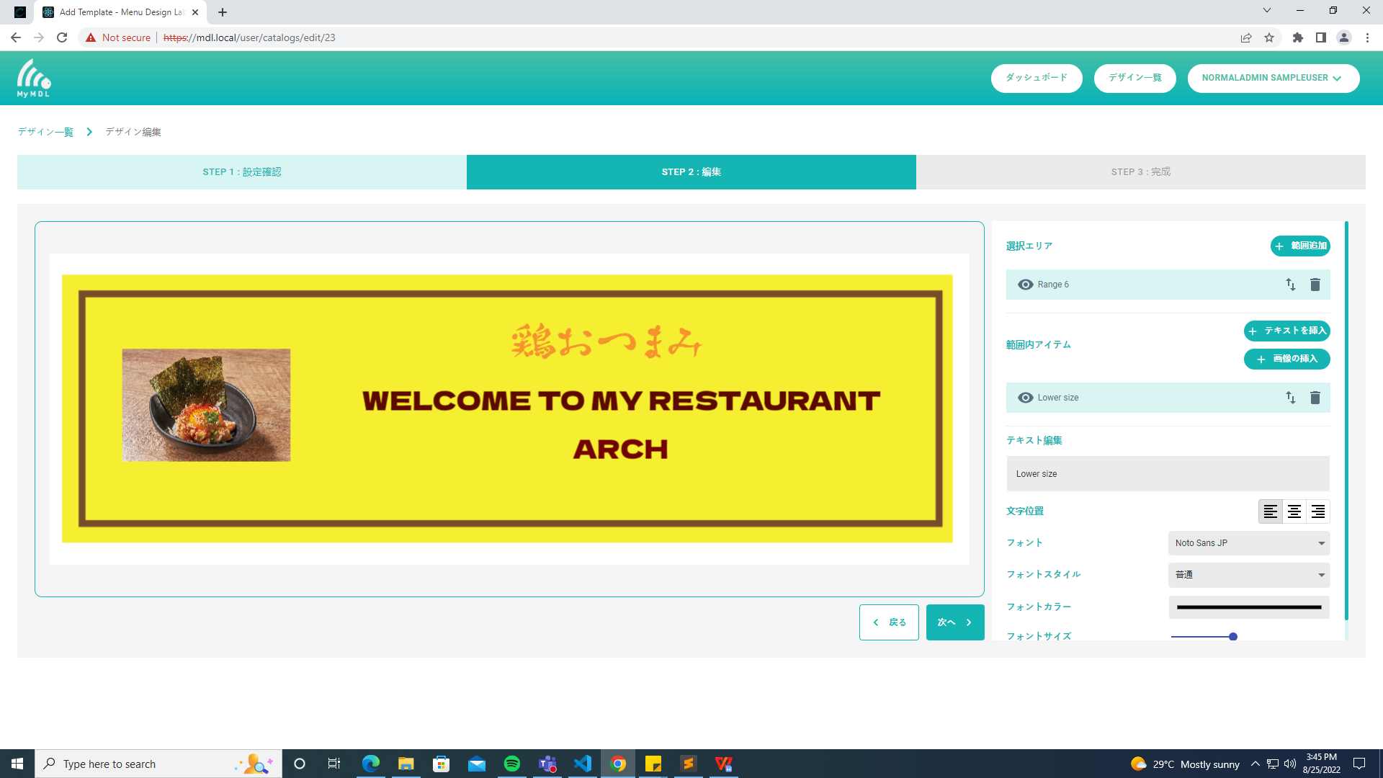

Step 2
450X300 EDIT,
CHANGED TO 900 X 300

BACK TO ORIGINAL TEMPLATE
Dili makita sa screen but naa ang layer

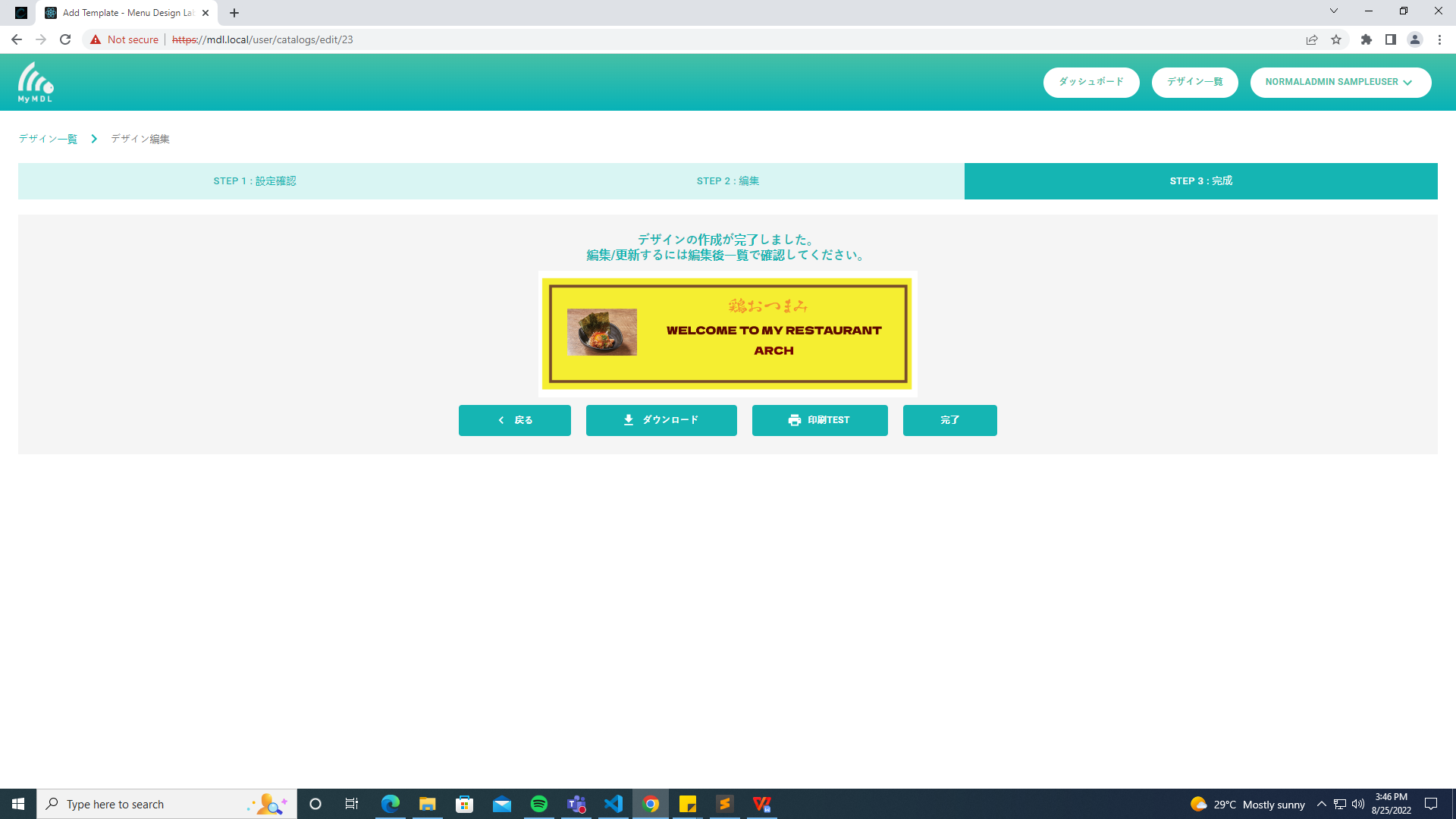

STEP 1 size 450 x 300 Change to lower size w297 x h210

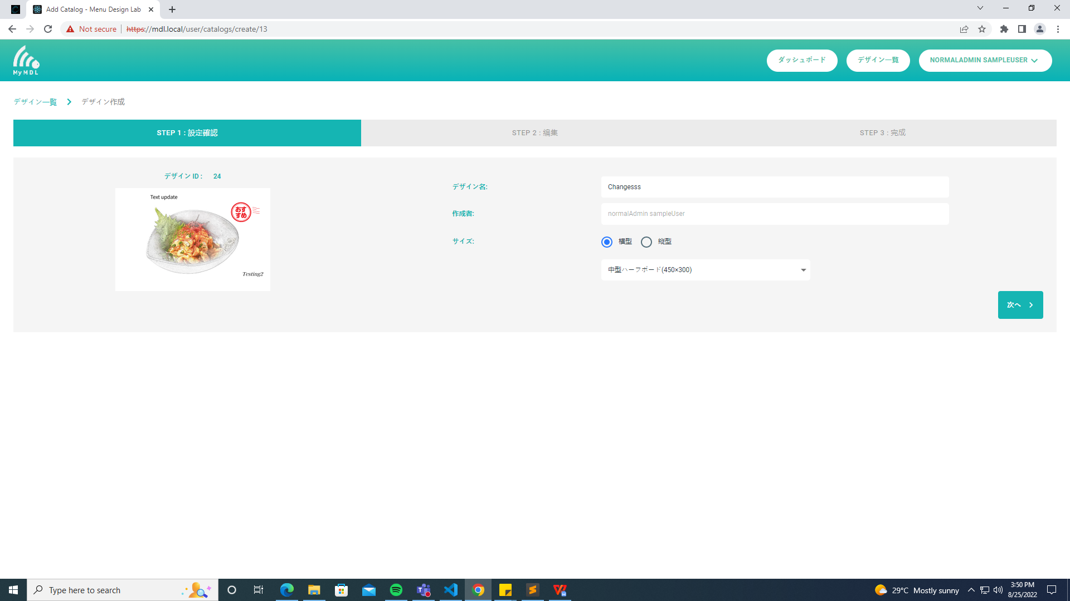

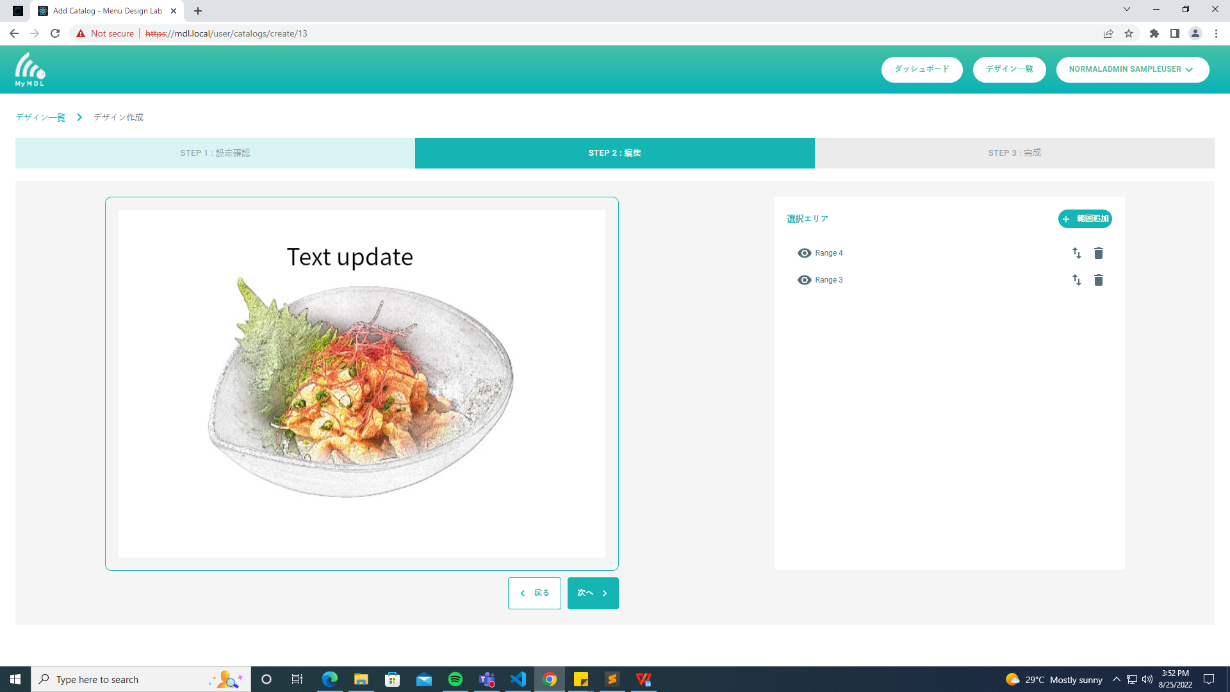

IMAGE NOT IF CLICK PREVIOUS BUTTON only step 1,
- click to step 2 not error

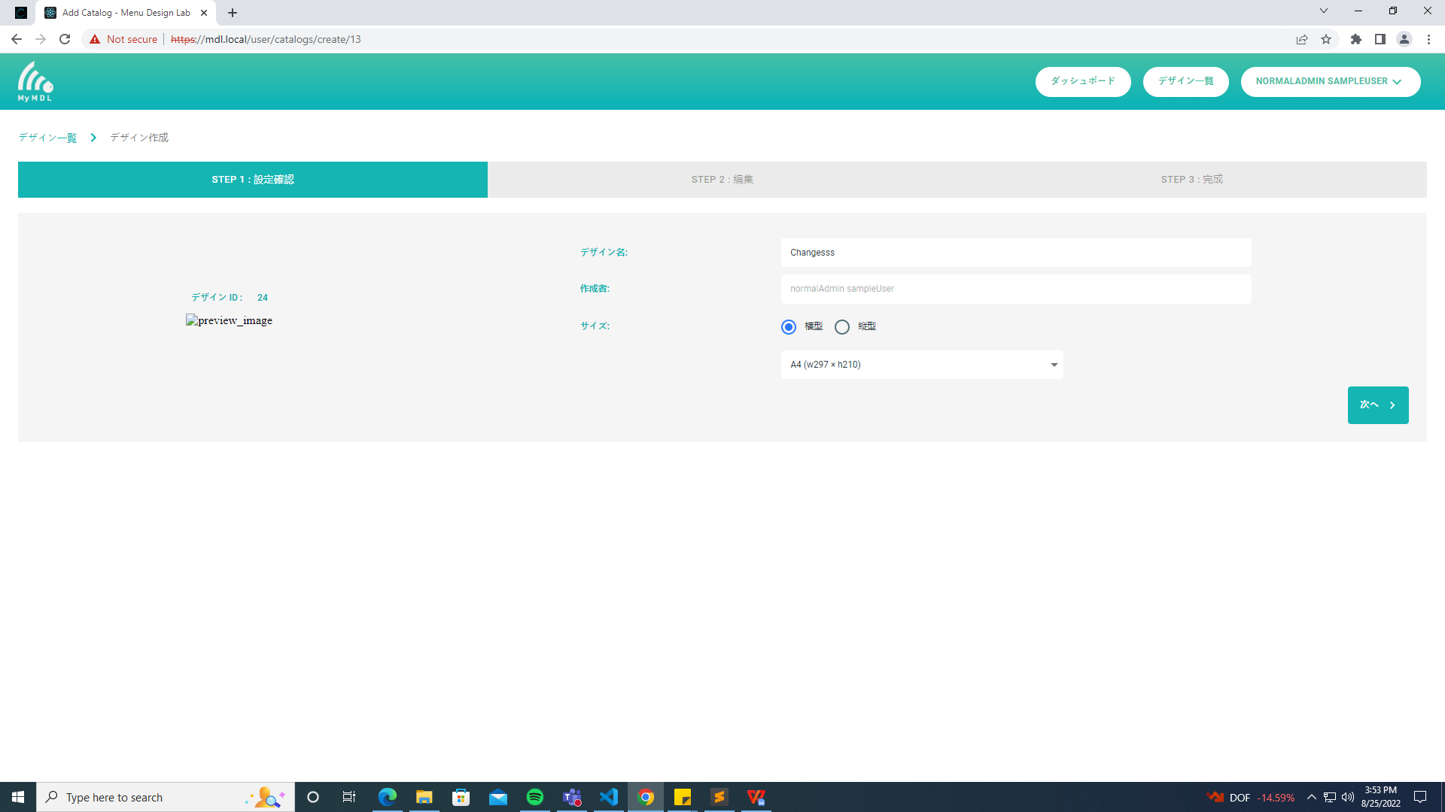

REACH STEP 3
NO ERRO BACK BUTTON, ANY SIZE DILI MA GUBA DESIGN\

